Distributed and Mobile Systems

Sem 1 2019

Zeting Luo: 16938158

My Phu Nguyen: 16933824

Contents

Technologies and Why 2

System Design 2

Overall Design 2

System components and used (please zoom in if you do not see the picture clear) 3

User Instruction 3

Environment require: 3

Preparation 3

Open Project 3

Config Glassfish Server 4

Build NetBeans projects 6

Project User Instructions 7

Project Student Client - Administration site 7

Project StudentApp – Student Client Site 10

# Technologies and Why

Languages: Java, xml

IDE: Netbeans 8.2

Web Service Server: Java Web Services deployed on GlassFish

Client Side Application: Java Web Applications

Messaging: JMS with GlassFish is JMS provider

The reasons we choose above technologies are varies. Firstly GlasshFish and Netbean are both free and go together. As AUT students we are familiar with them. Secondly, Netbean can provide part of generated xsd file for our objects so we do not have to 100% manually code wdsl and xsd files for SOAP web services. Finally ,with respect to JMS service, it is easy to configure in GlassFish . We can create Queue and Topic without having to create Maven Dependencies and downloading other Jar files from other JMS providers. It make the project less heavy.

# System Design

## Overall Design

The system present an Announcement System for Students. We have 1 Server (StudentServer which provide SOAP Web Services to 2 Applications . 2 Applications are StudentClient and StudentApp which consume the Web Services functions to operate.

Objects are serialised passed between Sever and Clients using SOAP with JAXB support.

StudentClient act like an Admin System for Student. It can add Student, view Student, and provide Announcement to Students. When StudentClient provide Announcement, it invoke Web Service method to produce JMS message that send Announcement object to StudentClient.

StudentClient provide login page for Student, receive JMS message from server to password validation and receive JMS Announcement object from WebServer

JMS messages between StudentServer and StudentApp are Point-to-Point message pattern. The messages are sent to the queue and can be received by specific client.

## System components and used (please zoom in if you do not see the picture clear)

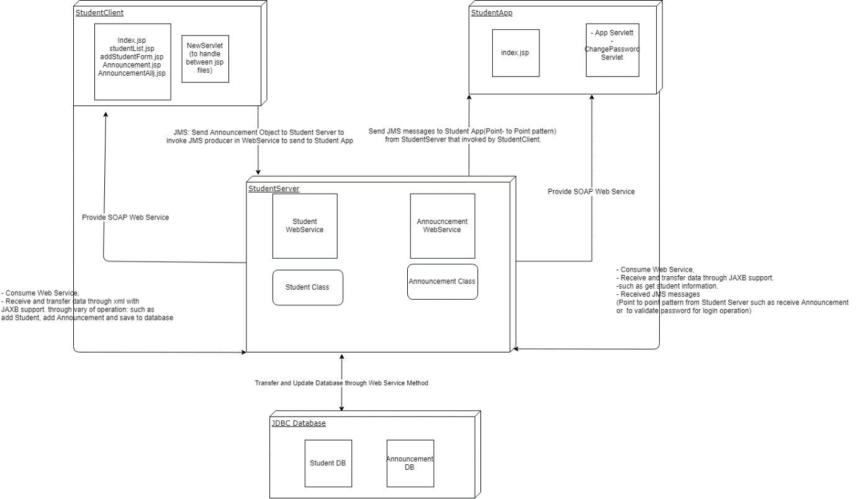

# User Instruction

## Environment require:

1. JDK 1.8 or higher
2. Glassfish 4.1.1
   1. For optimal result Glassfish 5.0
3. NetBeans 8.2

## Preparation

### Open Project

1. Unzip the project and open them in NetBeans
   1. After successfully open projects, you should see project structure like this  
      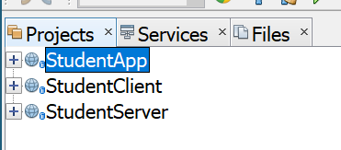
   2. Noticed that it is a chance that StudentApp project may shows it has error, but once all project import and build, error will go away  
      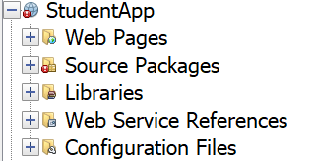

### Config Glassfish Server

1. Go to *Services* tag, and start Glassfish Server  
   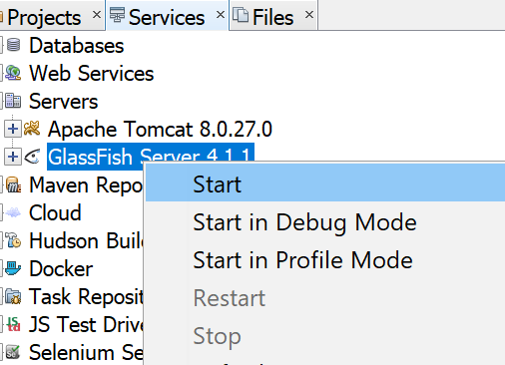
2. Wait for Glassfish server up and running, open the admin console  
   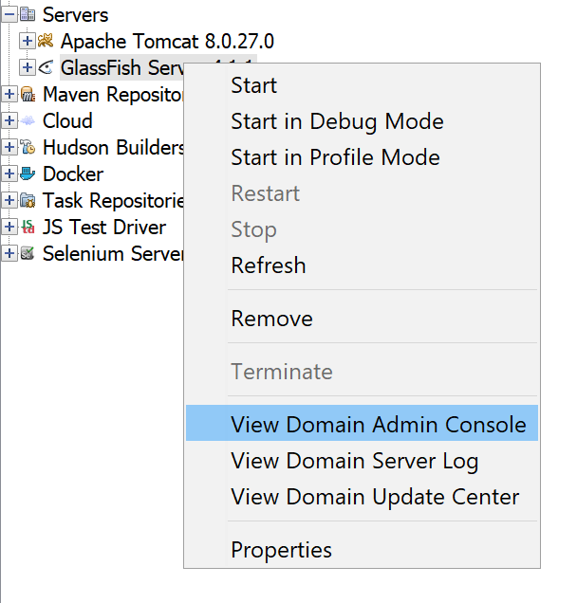
3. Open the *JMS Resources* tag located on the left and select *Connection Factories*  
   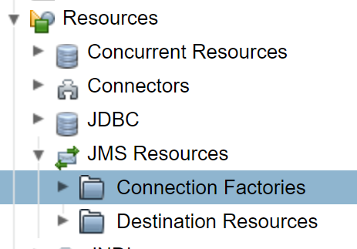
4. Make a new Connection Factory by click the *New* button and config it like the photo down below  
   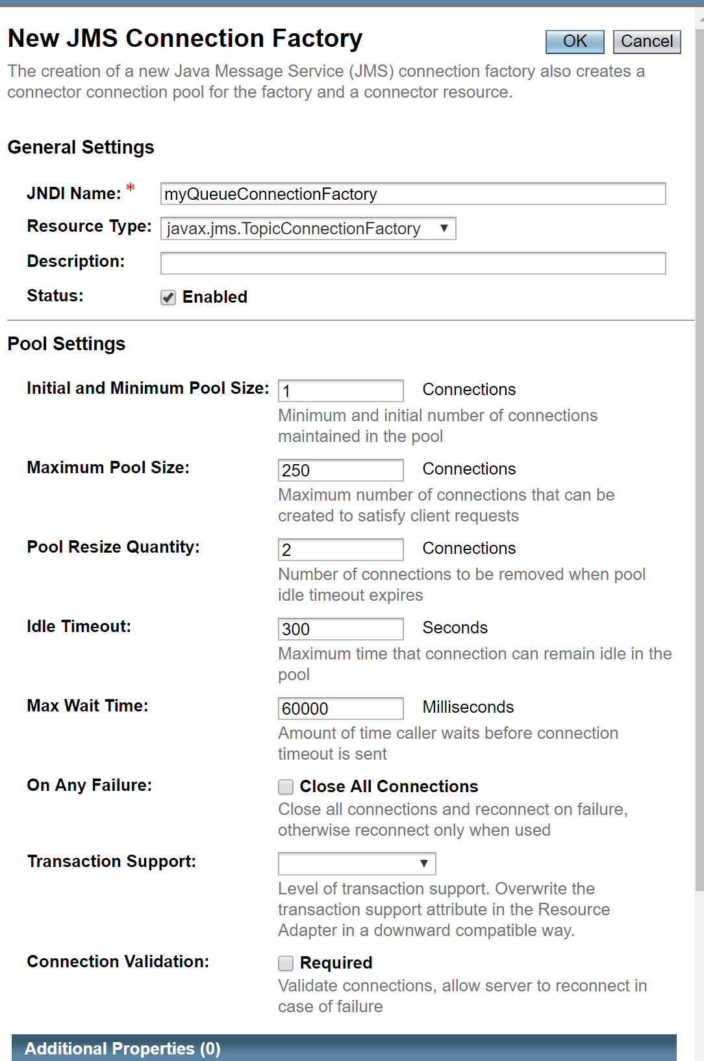
   1. Noticed that if you are running on Glassfish 4.1.1, it is a change that after you click the New button a run time error page shows up. If this happed, please upgrade you Glassfish server to 5.0.
   2. You can download Glassfish server from [***official website***](https://javaee.github.io/glassfish/download)
5. Open the *JMS Resources* tag located on the left and select *Destination Resources*  
   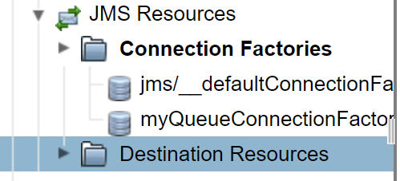
6. Click the *New* button to create a new queue, config is shown down below  
    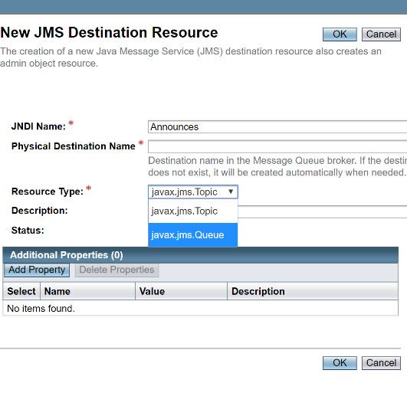
   1. Noticed that if you are running on Glassfish 4.1.1, it is a change that after you click the New button a run time error page shows up. If this happed, please upgrade you Glassfish server to 5.0.
   2. You can download Glassfish server from [***official website***](https://javaee.github.io/glassfish/download)
7. Once you finished your configuration, your JMS resources should look like this   
   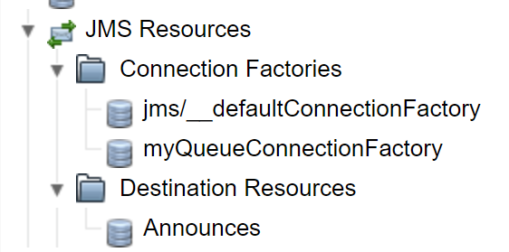

## Build NetBeans projects

1. Now, keep your Glassfish server running and go back to NetBeans, right click on project *StudentServer*, then select *deploy*   
   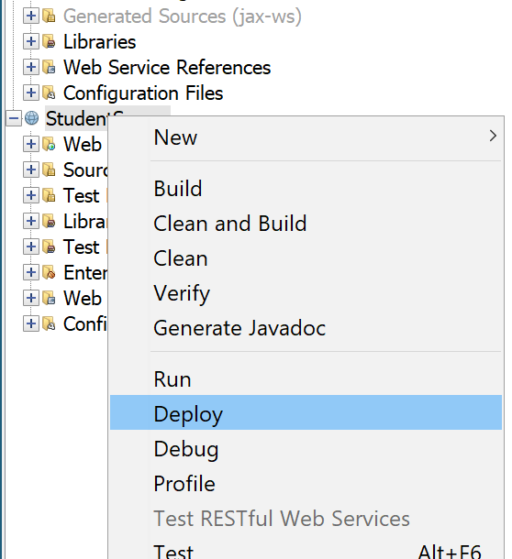
   1. Once server deploy, you should see console output like this   
      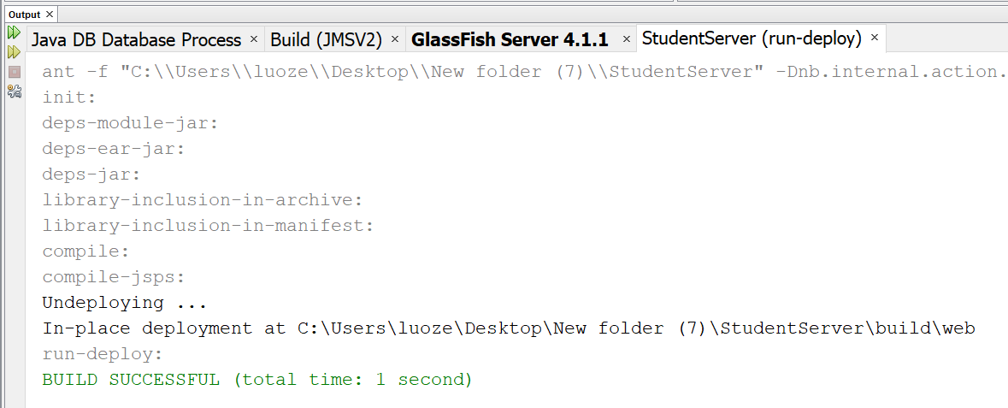
2. Do the same thing to *deploy* the *StudentClient* project, then right click on the project and select *Run*  
   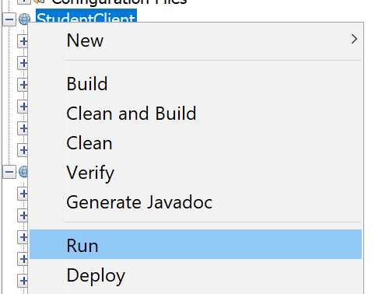
3. Once the project run, a browser windows should pop up, left it there and go back to NetBeans
   1. Windows should look like this  
      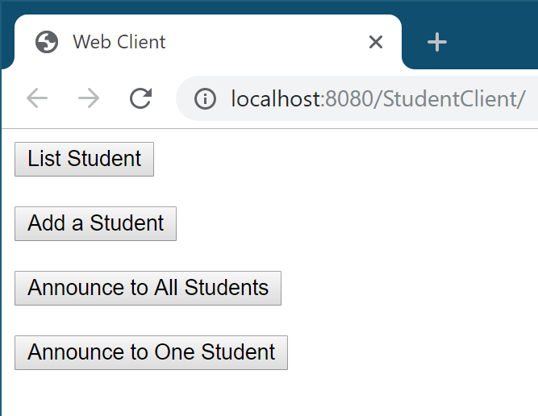
4. Right click *StudentApp* then select *Clean and Build*  
   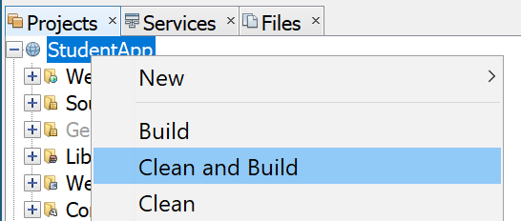
5. After it *build*, right click on the *StudentApp* project and click *Run*  
   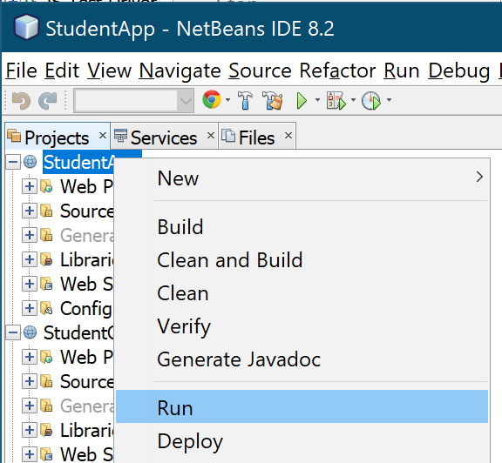
6. The second windows should pop up on browser
   1. Windows should look like this  
      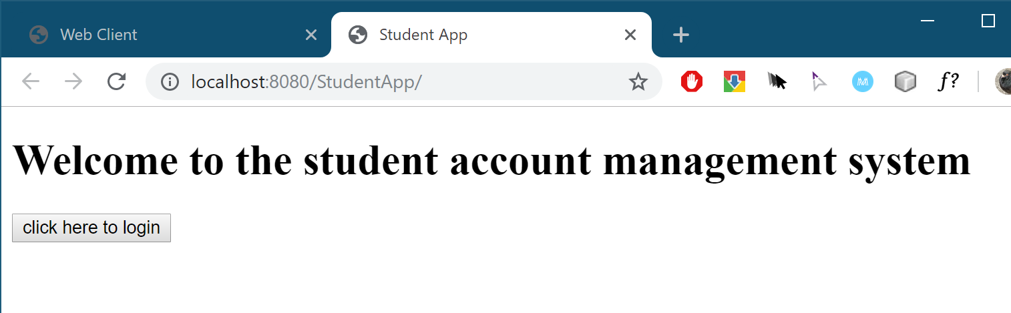

## Project User Instructions

### Project Student Client - Administration site

1. List student
   1. Click on the *list student* button   
      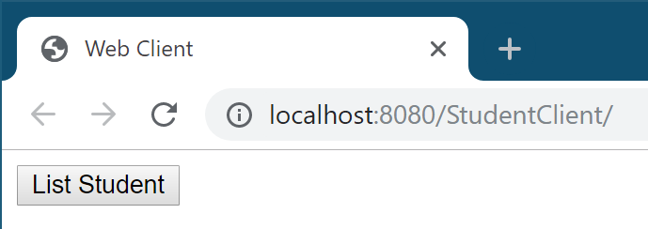
   2. Page will display all student information in database  
      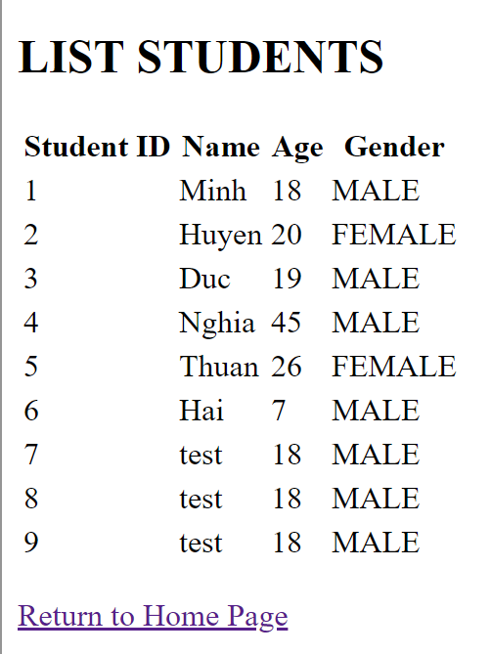
2. Add new Student
   1. Click Add a Student button  
      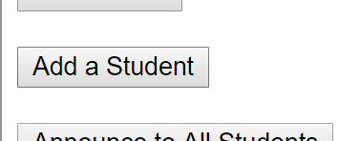
   2. Input information in the fields and click *add the student*, then student will be adding to student database  
      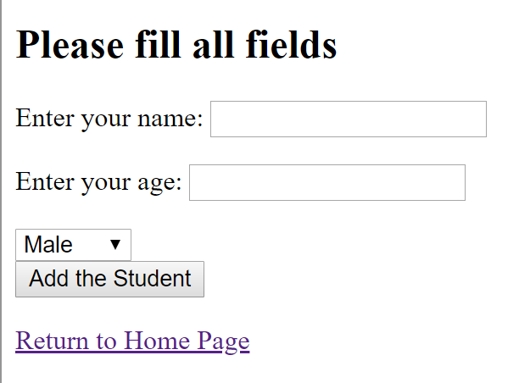
3. Send announcement without target
   1. Click *Announce to All Students* button  
      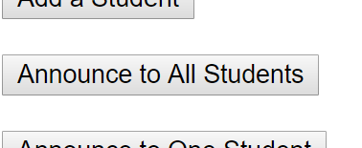
   2. Input information in the fields and click *Announce to All Student*  
      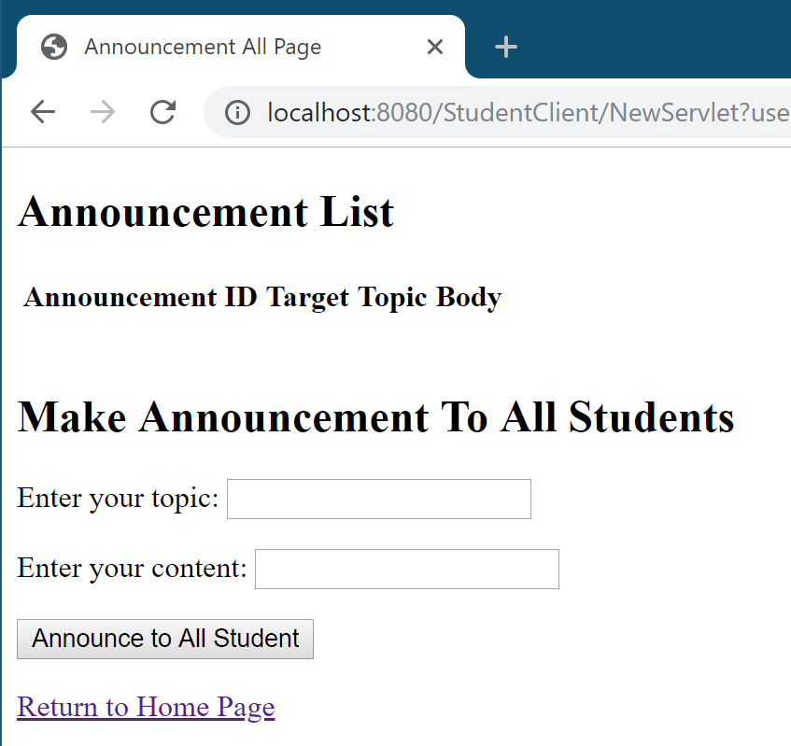
   3. JMS message will be push to the queue, page will reflash and you massage should show above  
      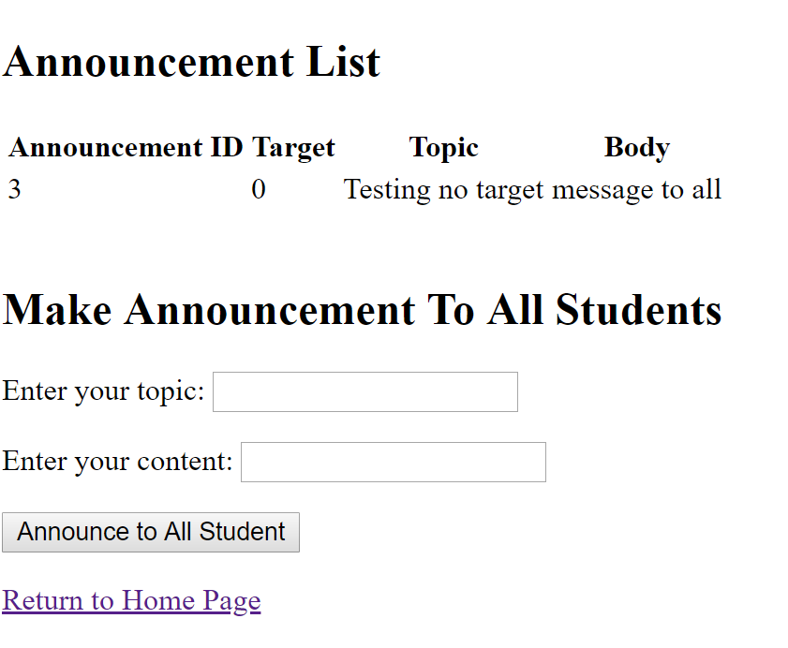
4. Send message to a student with student ID
   1. Click *Announce to One Student*  
      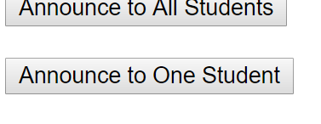
   2. Select student ID in the drop-down table and input information in the fields and click *Announce to this Student*  
      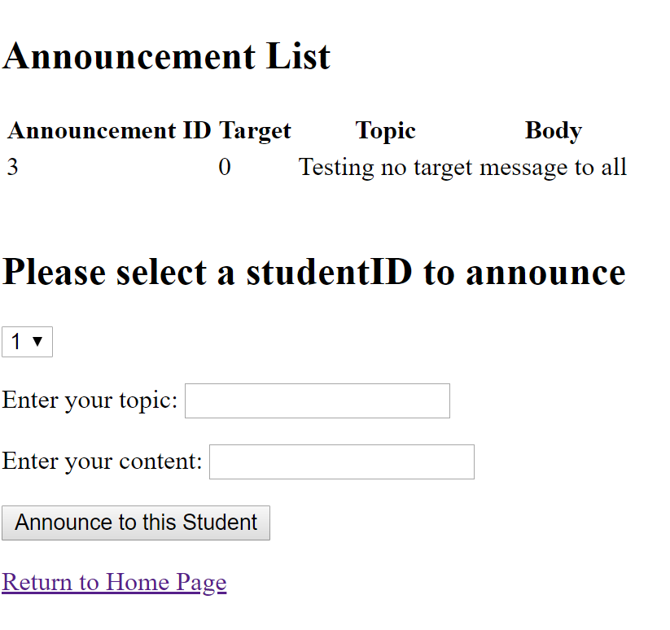
   3. JMS message will be push to the queue, page will reflash and you massage should show above  
      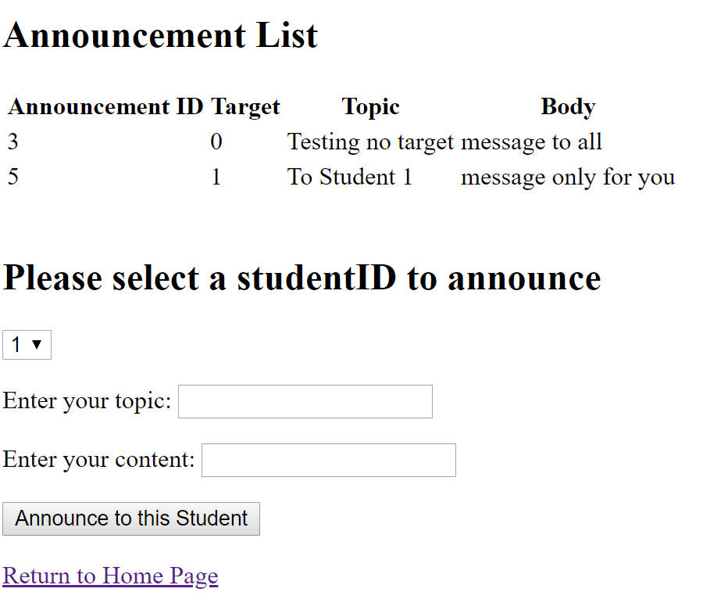

### Project StudentApp – Student Client Site

1. Welcome page, just click the button to login  
   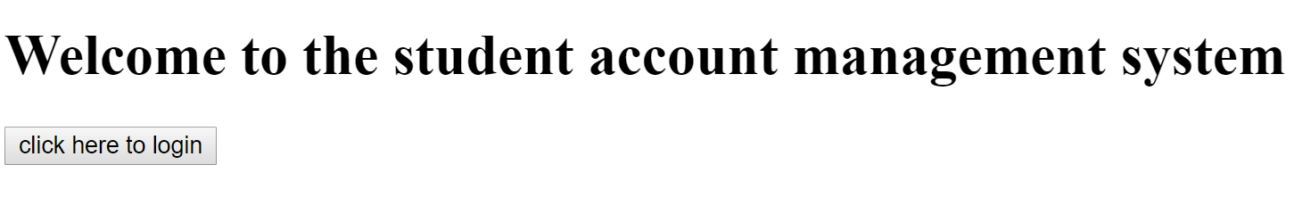
2. Login
   1. Input user name a password, then click the Login Here button  
      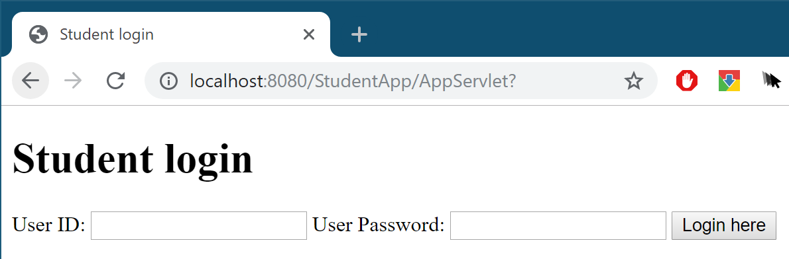
      1. For testing: you can use User ID 1, password 123 to test.
   2. If your password is correct you will be direct to view information page
   3. If your password is not correct, website will notice you like this  
      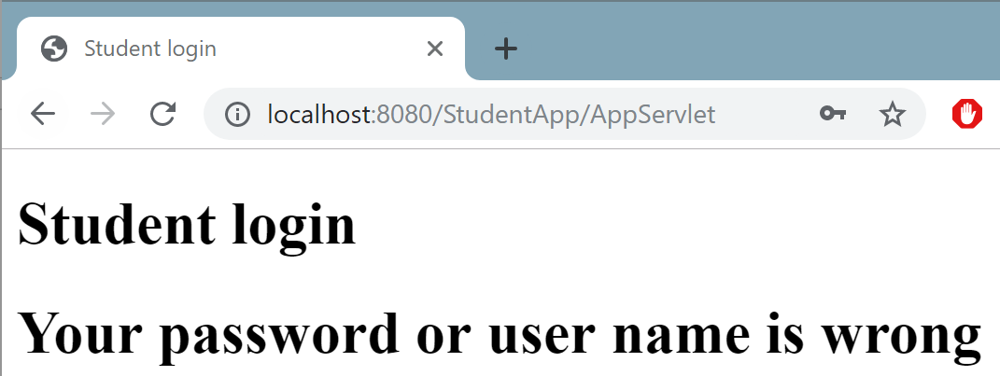
3. View information
   1. After login, you should see an information page like this  
      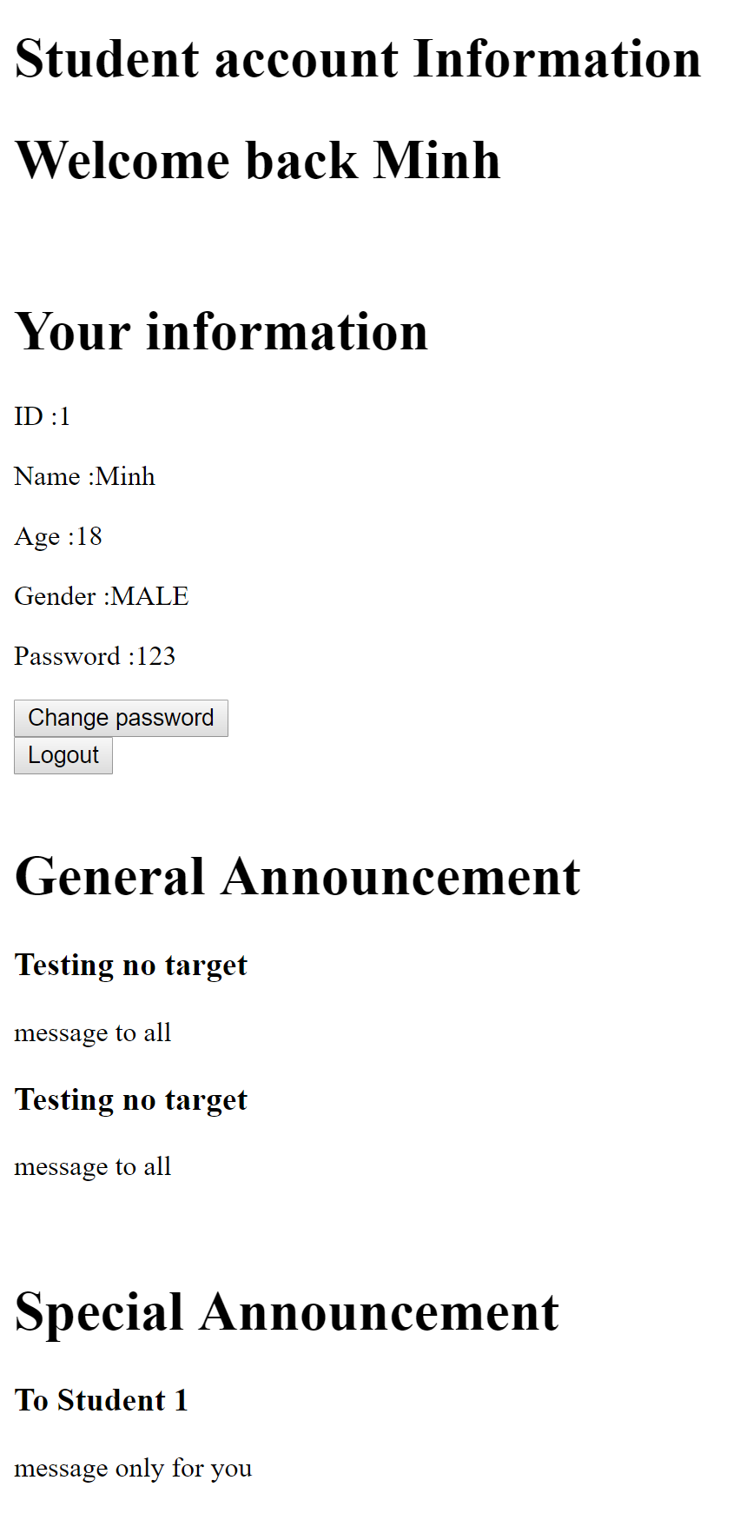
   2. Information can be display on this page and announcements can be display on this page
      1. General Announcement – all student can see
      2. Special Announcement – only student id matches the announcement can see
4. Change password
   1. Click the *Change Password* button on the page  
      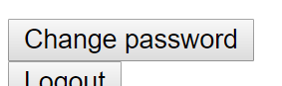
   2. Input new password and login again